TASK 1:
SET SERVEROUTPUT ON;
DECLARE
v_student_name VARCHAR2(50) := 'Ali';
v_course_name VARCHAR2(50) := 'Database Systems';
BEGIN
DBMS_OUTPUT.PUT_LINE('Student ' || v_student_name || ' is enrolled in ' || v_course_name);
END;
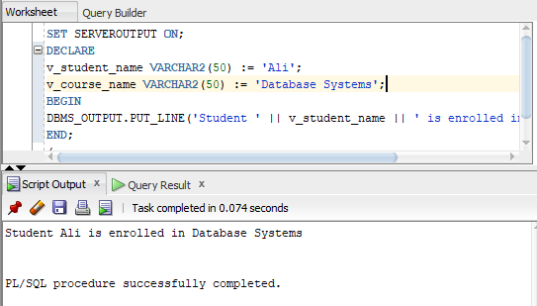
/

TASK 2:
DECLARE
a NUMBER := 20;
b NUMBER := 10;
c NUMBER := 5;
sum_result NUMBER;
sub_result NUMBER;
div_result NUMBER;
BEGIN
sum_result := a + b + c;
sub_result := a - b - c;
div_result := a / c;
DBMS_OUTPUT.PUT_LINE('Addition: ' || sum_result);
DBMS_OUTPUT.PUT_LINE('Subtraction: ' || sub_result);
DBMS_OUTPUT.PUT_LINE('Division: ' || div_result);
END;
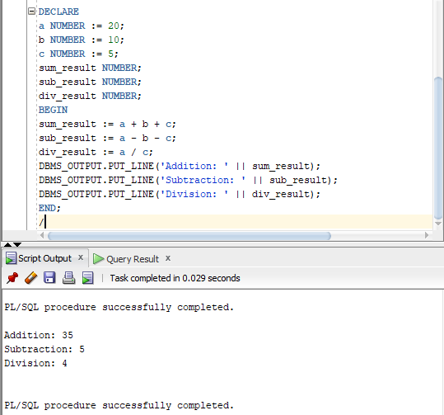
/

TASK 3:
DECLARE
x NUMBER := 10;
y NUMBER := 20;
BEGIN
DBMS_OUTPUT.PUT_LINE('Outer Block: x = ' || x || ', y = ' || y);
DECLARE
x NUMBER := 100;
y NUMBER := 200;
BEGIN
DBMS_OUTPUT.PUT_LINE('Inner Block: x = ' || x || ', y = ' || y);
END;
DBMS_OUTPUT.PUT_LINE('Outer Block Again: x = ' || x || ', y = ' || y);
END;
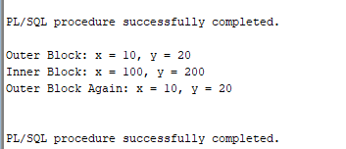
/

TASK 4:
DECLARE
v_fname hr.employees.first_name%TYPE;
v_salary hr.employees.salary%TYPE;
BEGIN
SELECT first_name, salary INTO v_fname, v_salary
FROM hr.employees
WHERE employee_id = 100;

DBMS_OUTPUT.PUT_LINE('Name: ' || v_fname);
DBMS_OUTPUT.PUT_LINE('Salary: ' || v_salary);
END;
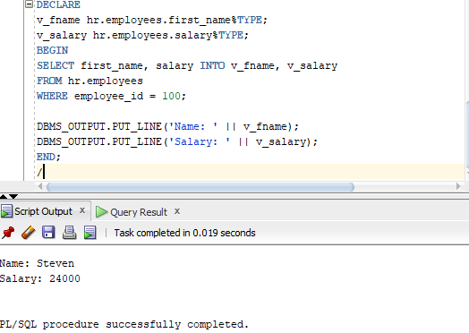
/

TASK 5:
DECLARE
v_salary hr.employees.salary%TYPE;
BEGIN
SELECT salary INTO v_salary
FROM hr.employees
WHERE employee_id = 100;
IF v_salary > 10000 THEN
v_salary := v_salary + 500;
DBMS_OUTPUT.PUT_LINE('Salary updated to: ' || v_salary);
ELSE
DBMS_OUTPUT.PUT_LINE('Salary not updated: ' || v_salary);
END IF;
END;
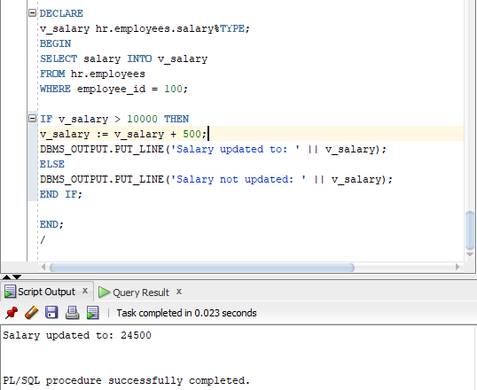
/

TASK 6:
DECLARE
v_salary hr.employees.salary%TYPE;
BEGIN
SELECT salary INTO v_salary
FROM hr.employees
WHERE employee_id = 100;
IF v_salary <= 10000 THEN
v_salary := v_salary + 500;
ELSIF v_salary <= 20000 THEN
v_salary := v_salary + 300;
ELSE
v_salary := v_salary + 100;
END IF;
DBMS_OUTPUT.PUT_LINE('Updated Salary: ' || v_salary);
END;
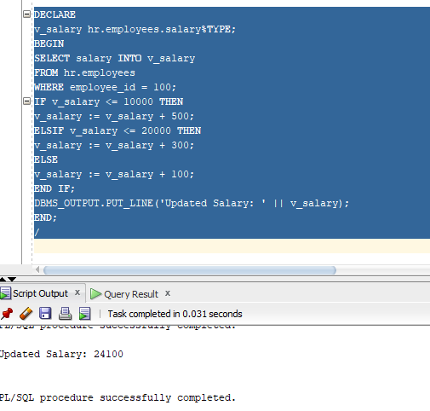
/
TASK 7:
DECLARE
v_dept hr.employees.department_id%TYPE;
v_bonus NUMBER;
BEGIN
SELECT department_id INTO v_dept
FROM hr.employees
WHERE employee_id = 100;
CASE v_dept
WHEN 10 THEN v_bonus := 1000;
WHEN 20 THEN v_bonus := 800;
WHEN 30 THEN v_bonus := 600;
ELSE v_bonus := 400;
END CASE;
DBMS_OUTPUT.PUT_LINE('Bonus: ' || v_bonus);
END;
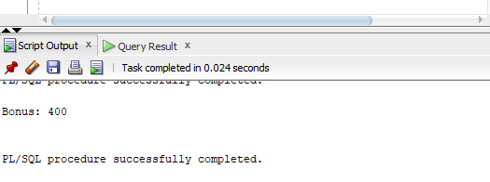
/

TASK 8:
DECLARE
v_salary hr.employees.salary%TYPE;
v_dept hr.employees.department_id%TYPE;
BEGIN
SELECT salary, department_id INTO v_salary, v_dept
FROM hr.employees
WHERE employee_id = 100;
IF v_dept = 10 THEN
IF v_salary > 10000 THEN
v_salary := v_salary + 1000;
END IF;
END IF;
DBMS_OUTPUT.PUT_LINE('Final Salary: ' || v_salary);
END;
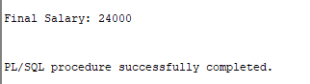
/

TASK 9:
DECLARE
BEGIN
FOR emp_rec IN (SELECT first_name, salary FROM hr.employees WHERE department_id = 10)
LOOP
DBMS_OUTPUT.PUT_LINE('Name: ' || emp_rec.first_name || ', Salary: ' || emp_rec.salary);
END LOOP;
END;
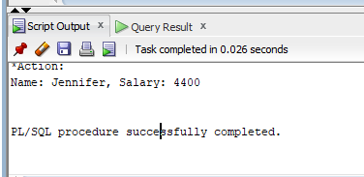
/

TASK 10:
CREATE OR REPLACE PROCEDURE get_salary(
p_emp_id IN hr.employees.employee_id%TYPE,
p_salary OUT hr.employees.salary%TYPE
)
IS
BEGIN
SELECT salary INTO p_salary
FROM hr.employees
WHERE employee_id = p_emp_id;
END;
/
DECLARE
v_salary hr.employees.salary%TYPE;
BEGIN
get_salary(100, v_salary);
DBMS_OUTPUT.PUT_LINE('Salary: ' || v_salary);
END;



